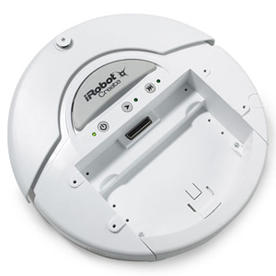
Navigation Lab: Set Up
Power Up
BlueTooth Address

Power Up:
- Remove robot from charger.
- Power up robot.
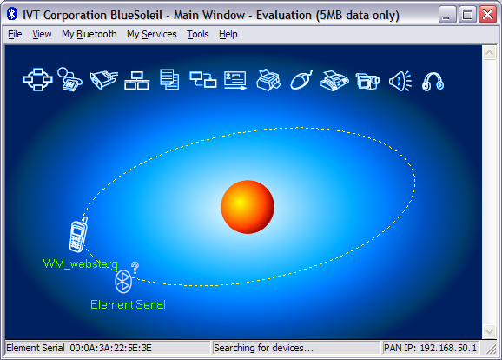

Detect Bluetooth connection:
When asked about AutoConnect, say no
- Double click desktop BlueSoleil icon. When prompted about security: uncheck medium
If no window opens, double-click the Bluetooth icon on the task bar.
- View/Refresh devices
- Identify your robot (Element Serial with same Bluetooth address as printed on robot’s receiver)
- Right click: Pair device (passkey: 0000)
- Right click: Refresh Services
- Right click: Connect BluetoothSerialService.
- Click NO when asked about Automatic Connection.
Note: the number of the serial port you are connected to (ex: COM8)

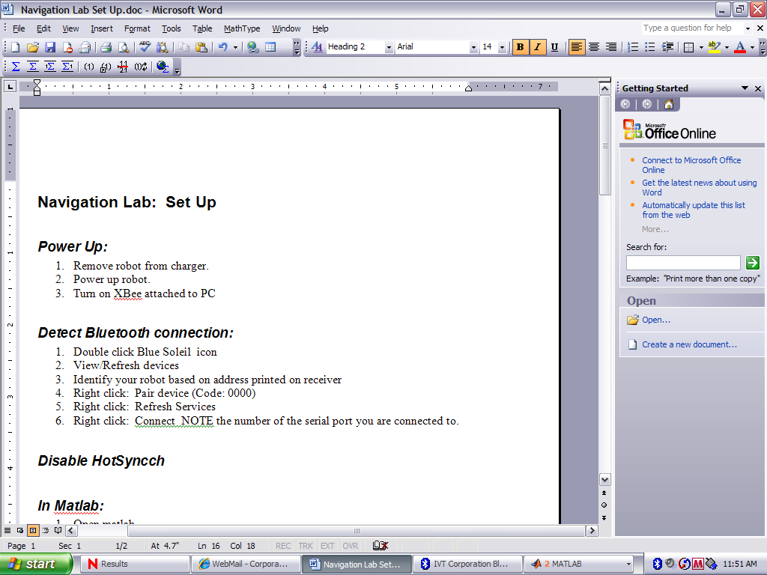
Disable HotSynch
Right click on the hot synch icon in the system tray. Click Exit.

In Matlab (do not start Matlab until you have established a Bluetooth connection!)
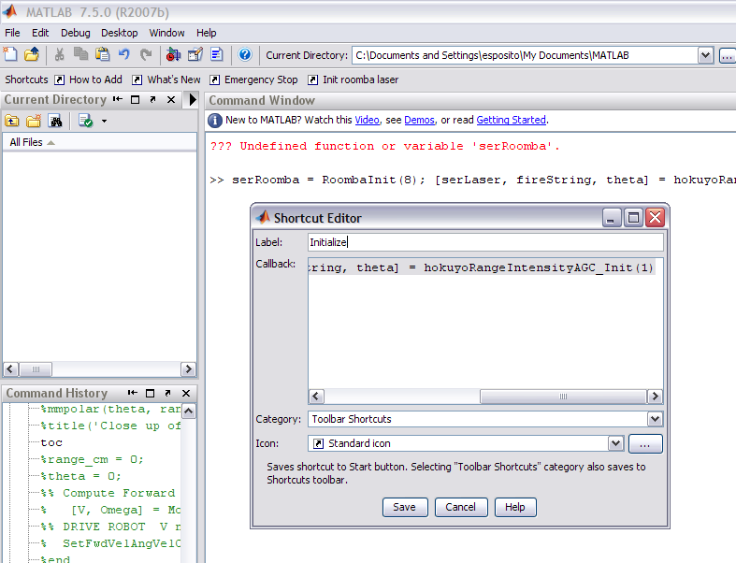
- Add a path (directory) Type:
>> addpath ‘N:\ES450\create\’; >>savepath;
- Initialize Laser and Roomba. Substitute your serial port number for the 8. Type: >> serRoomba = RoombaInit(8);

- Wait…wait… You should hear the robot beep and both outboard lights should turn on.

- Tip: Highlight the entire line from step 2 and drag it to the toolbar to create a shortcut button for this step. Name it “Initialize”.
- Create an emergency stop button:
Type >>SetFwdVelAngVelCreate(serRoomba, 0, 0);
Highlight the entire line and drag to toolbar.
Name this shortcut “Emergency Stop”.

Note: If you restart Matlab, you will have to click your Initialize Shortcut to reinitialize the hardware.
Note: If you power cycle the robot you have to go back to the BlueSoleil Window and right click your robot, select Connect. Then click your Initialize Shortcut to reinitialize the hardware.
Note: As you start writing code, if you want to stop the robot, use Cntrl-C to abort the code, then press the emergency stop button to stop the robot.

